**Test Case** **0003**

**System:** VirtuCardsClient & VirtuCardsHost

**Description:** Tests that the client can send public messages

**Severity:** 3

**Instructions**

**Test1**

1. Start VirtuCardClient application
2. Click the button labeled “Sign In”
3. Enter “virtucards01@gmail.com” into the text input labeled “Enter email…”
4. Enter “Testing1” into the text input labeled “Enter password…”
5. Press the button labeled “Login”
6. A window should appear saying “Login Success”
7. Press the OK button that appears on that window
8. Start VirtuCardHost application
9. Repeat steps 2-7 but on the VirtuCardHost application
10. The checkbox “Allow Host to Join” should be checked on the host
11. Select the “Freeplay” option from the game choices dropdown
12. Press the Create Game button
13. In the VirtuCardClient application enter the 6-character room code found on the host’s screen into the field labeled “Enter Code…”
14. Press the Join Game button on the client
15. Press the Start Game button on the host
16. On the client side, enter the text “Hello There” into the field labeled “Enter Message Here…”
17. Press the Send button on the client

**Expected Result:** A message should appear on the host side saying “Hello There” with the username “TestCase0001” displayed as the sender

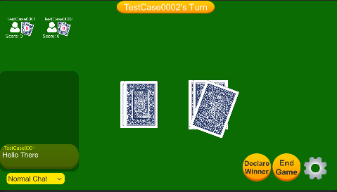 **Host View**

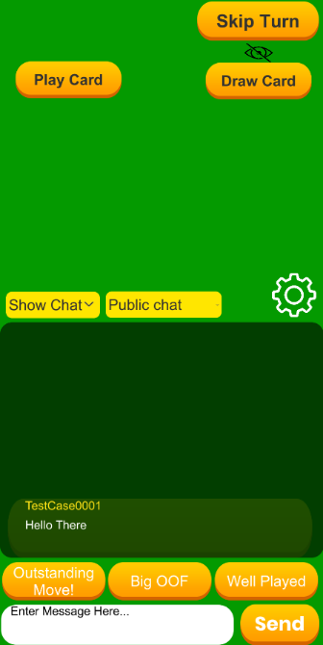 **Client View**

**Test2**

1. Start VirtuCardClient application
2. Click the button labeled “Sign In”
3. Enter “virtucards01@gmail.com” into the text input labeled “Enter email…”
4. Enter “Testing1” into the text input labeled “Enter password…”
5. Press the button labeled “Login”
6. A window should appear saying “Login Success”
7. Press the OK button that appears on that window
8. Start a second VirtuCardHost application
9. Repeat steps 2-7, but use “virtucards02@gmail.com” as the email and use “Testing1” as the password.
10. Start VirtuCardHost application
11. Repeat steps 2-7 but on the VirtuCardHost application
12. The checkbox “Allow Host to Join” should be checked on the host
13. Select the “Freeplay” option from the game choices dropdown
14. Press the Create Game button
15. In the first VirtuCardClient application enter the 6-character room code found on the host’s screen into the field labeled “Enter Code…”
16. Press the Join Game button after it has loaded
17. Repeat previous two steps except on the second VirtuCardClient application
18. Press the Start Game button on the host application
19. On one client, enter the text “Hello There” into the field labeled “Enter Message Here…”
20. Press the Send button on the client

**Expected Result:** Both the host and each of the clients should have their chat windows contain “Hello There” sent by the username of the client who the chat originated from.

 **Host View**

 **Client View**

**Test3**

1. Start VirtuCardClient application
2. Click the button labeled “Sign In”
3. Enter “virtucards01@gmail.com” into the text input labeled “Enter email…”
4. Enter “Testing1” into the text input labeled “Enter password…”
5. Press the button labeled “Login”
6. A window should appear saying “Login Success”
7. Press the OK button that appears on that window
8. Start a second VirtuCardHost application
9. Repeat steps 2-7, but use “virtucards02@gmail.com” as the email and use “Testing1” as the password.
10. Start VirtuCardHost application
11. Repeat steps 2-7 but on the VirtuCardHost application
12. The checkbox “Allow Host to Join” should be checked on the host
13. Select the “Freeplay” option from the game choices dropdown
14. Press the Create Game button
15. In the first VirtuCardClient application enter the 6-character room code found on the host’s screen into the field labeled “Enter Code…”
16. Press the Join Game button after it has loaded
17. Repeat previous two steps except on the second VirtuCardClient application
18. Press the Start Game button on the host application
19. On one client, enter the text “Hello There” into the field labeled “Enter Message Here…”
20. Press the Send button on the client
21. On the same client, enter the text “Hello There2” into the field labeled “Enter Message Here…”
22. Press the Send button on the client
23. On the same client, enter the text “Hello There3” into the field labeled “Enter Message Here…”
24. Press the Send button on the client
25. On the same client, enter the text “Hello There4” into the field labeled “Enter Message Here…”
26. Press the Send button on the client

**Expected Result:** Both the host and each of the clients should have their chat windows completely filled with “Hello There” “Hello There2” “Hello There3” and “Hello There4”

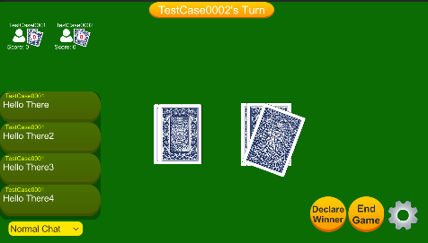 **Host View**

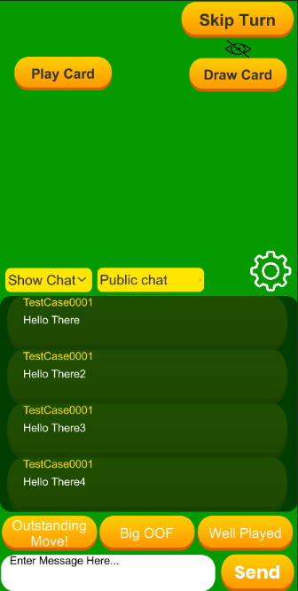 **Client View**

**Test4**

1. Start VirtuCardClient application
2. Click the button labeled “Sign In”
3. Enter “virtucards01@gmail.com” into the text input labeled “Enter email…”
4. Enter “Testing1” into the text input labeled “Enter password…”
5. Press the button labeled “Login”
6. A window should appear saying “Login Success”
7. Press the OK button that appears on that window
8. Start a second VirtuCardHost application
9. Repeat steps 2-7, but use “virtucards02@gmail.com” as the email and use “Testing1” as the password.
10. Start VirtuCardHost application
11. Repeat steps 2-7 but on the VirtuCardHost application
12. The checkbox “Allow Host to Join” should be checked on the host
13. Select the “Freeplay” option from the game choices dropdown
14. Press the Create Game button
15. In the first VirtuCardClient application enter the 6-character room code found on the host’s screen into the field labeled “Enter Code…”
16. Press the Join Game button after it has loaded
17. Repeat previous two steps except on the second VirtuCardClient application
18. Press the Start Game button on the host application
19. On one client, enter the text “Hello There” into the field labeled “Enter Message Here…”
20. Press the Send button on the client
21. On the same client, enter the text “Hello There2” into the field labeled “Enter Message Here…”
22. Press the Send button on the client
23. On the same client, enter the text “Hello There3” into the field labeled “Enter Message Here…”
24. Press the Send button on the client
25. On the same client, enter the text “Hello There4” into the field labeled “Enter Message Here…”
26. Press the Send button on the client
27. On the same client, enter the text “Hello There5” into the field labeled “Enter Message Here…”
28. Press the Send button on the client

**Expected Result:** Both the host and each of the clients should have their chat windows completely filled with “Hello There2” “Hello There3” “Hello There4” and “Hello There5”. The “Hello There” message should have been removed.

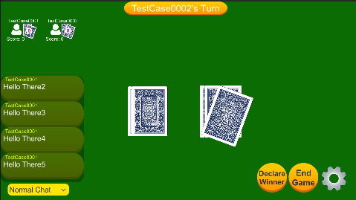 **Host View**

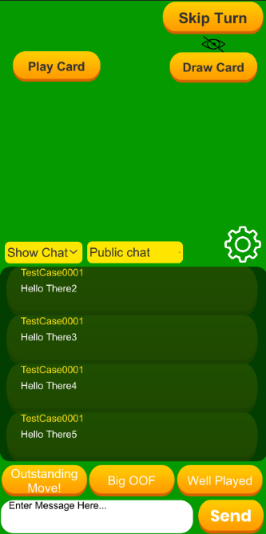 **Client View**